Life on Earth

Earth Science Study Guide Study GUide

Modern Biodiversity

Study Tip

Habitats and Niches

Think about the characteristics humans have developed. Why do they make our lives easier?

* Many species have adapted to their habitats and filled unique niches.
* 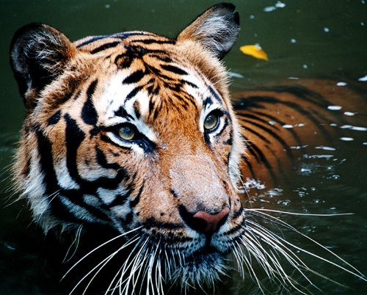These unique features allow plants and animals to have advantages in their environment such as protection from their surroundings or the ability to gather food. Some adaptations allow organisms to defend themselves from predators or attract a mate as well.

The Animal Kingdom

* There are plenty of examples of these adaptations in the Animal Kingdom. All of these animals demonstrate how they have filled niches in their environments.
  + Bats have the ability of echolocation that allows them to track down food in the dark.
  + Giraffes’ long necks can reach the leaves on tall trees.

A Tiger’s stripes allow it to blend in with tall grass, making it a very dangerous predator.

* + The bright colors on a poison dart frog warn predators to stay away from it due to its toxins.
  + The elaborate feathers of a peacock allow it to attract a mate with ease.
* Animals aren’t the only species that can adapt to environments. Many plants have filled niche roles as well. These adaptations allow plants to spread their seeds or pollen, gather more sunlight, defend themselves from animals, and, in the case of carnivorous plants, eat small insects for nutrients.

The spines on cacti prevent animals from trying to make there home in these plants.

Concept Check

* What is the importance of adaptation?
* What are some examples of adaptation in animals and plants?